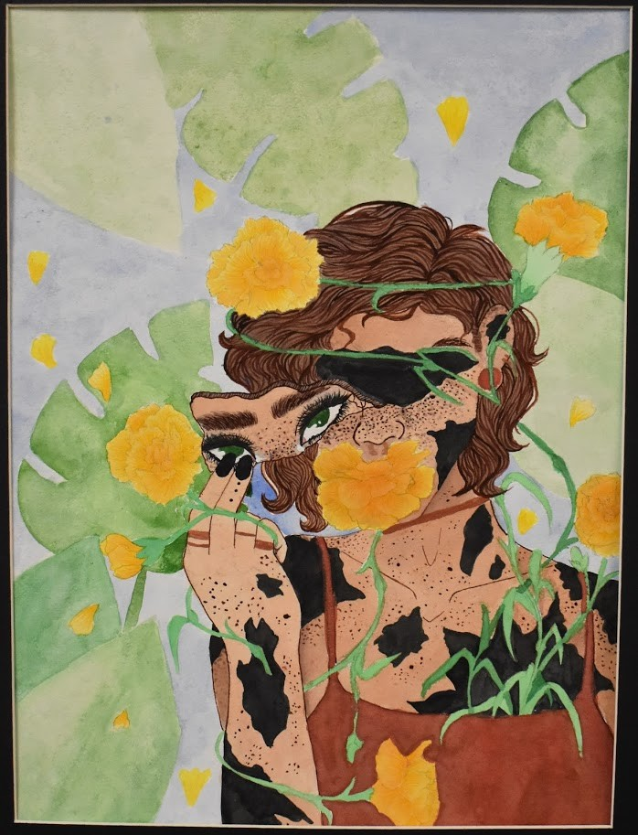

RECEPTION & AWARDS CEREMONY

Gallery of submitted works will be posted on MHA of Greater Houston's Facebook Page

https://www.facebook.com/ MHAGreaterHouston/
The art showcase is an annual celebration and awareness event highlighting the importance of protecting children’s mental health. The showcase is open to greater Houston area youth ages 5 to 20 reflecting the theme “Art in the Face of COVID-19"
3RD ANNUAL YOUTH MENTAL HEALTH
ART SHOWCASE

RULES AND ELIGIBILITY

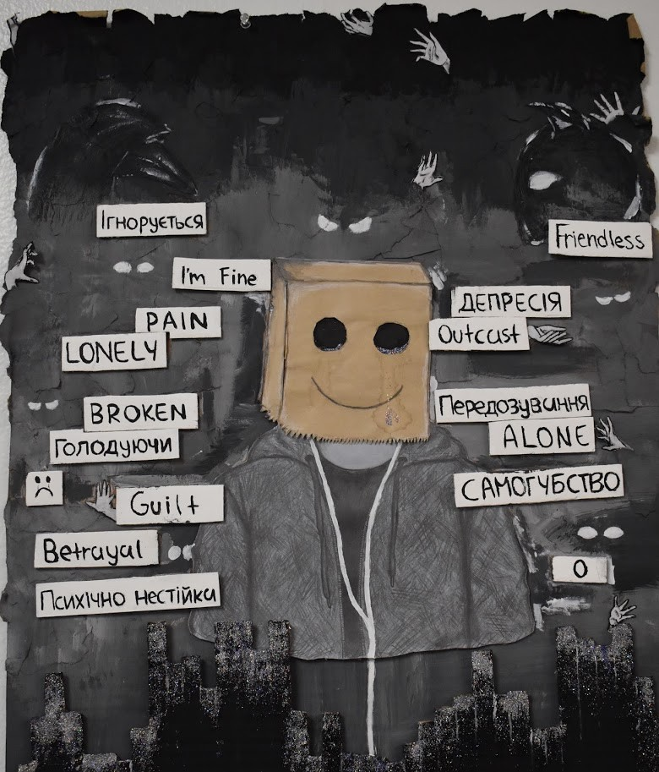
- Original artwork accepted includes collage, drawings, mixed media, mosaics, needlework, paint, photography, and 3-D.
- Artwork must reflect the theme “Art in the Face of COVID-19” and will be judged based on originality and impact of message.
- Pieces must not contain vulgar language, nudity, or lewd/suggestive images or phrases.
- Parents may submit art on behalf of their children
- Only one submission per student will be accepted. Photographs or scanned copies of pieces along with a completed consent form must be submitted to csbhinfo@mhahouston.org in order to be posted on our virtual gallery located at https:// www.facebook.com/MHAGreaterHouston/
- Questions or concerns should be directed to CSBHinfo@mhahouston.org or by phone to 713-523-8963 ext. 243

CONSENT FORM

***One form per submission***

Youth's Name and Age:
Title of Artwork submitted: Type of Artwork submitted: Description of the Art:

Parent Signature (to allow for publication release):

Consent Statement (if over 18, please sign below to accept):

I,
give permission for
to participate

in the 2020 Children’s Mental Health Art Showcase. I consent that the original artwork can be reproduced in digital image form for publicity purposes by Mental Health America of Greater Houston and I grant permission to interview me and/or my child in any official publicity opportunities. Publicity use includes but is not limited to news releases, publications, videos, social media, for fundraising purposes and website in perpetuity.

Parent/Guardian’s Name (Printed) Parent/Guardian’s Signature Date:

_____________________________________________ ______________________________________________ _________________________________

