Share this Contest via Social Media
Step 1: Choose a social media post
We need your help to #StoptheSpread! We're looking for K-12 students to submit the most creative, energetic ways to promote #HealthyHabits during #COVID19. Send us your videos, paintings, picture and you could win a cash prize! Want more info? Click here: https://sph.uth.edu/landing/covid-youth/
Helping #StoptheSpread can be as easy as lights, camera, action! K-12 students, send in your best videos, paintings or other creative pieces that show how to practice #HealthyHabits during #COVID19 and you could win a cash prize! Click here for more info: https://sph.uth.edu/landing/covid-youth/
You can help #StoptheSpread by showing your #communities how it's done! We're looking for K-12 students to send in creative messages about practicing #HealthyHabits during #COVID19 for the chance to win cash! Click here for more details and inspiration! https://sph.uth.edu/landing/covid-youth/
Your creativity could help save lives! We're looking for K-12 students who can show creative ways of practicing #HealthyHabits during #COVID19. Send in your project and you could win a cash prize! Click here for more info: https://sph.uth.edu/landing/covid-youth/
Step 2: Add a picture (Facebook or Instagram)
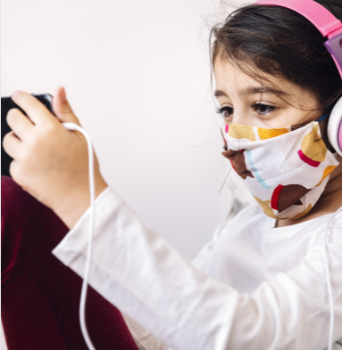
Step 3: Send it out to encourage all of your followers to participate!

