Coffee & Quality Learning Cohort (CQLC) purpose: As an extension of Coffee & Quality, the Learning Cohort will provide an opportunity for United Way of Greater Houston to deepen and strengthen capacity building efforts among agency staff centered around data, evaluation, and continuous quality improvement (CQI).

The Coffee & Quality Learning Cohort (CQLC) is designed as a community of practice to improve professional competency by engaging in shared inquiry and learning around a specific topic related to data, evaluation, and CQI. The CQLC will be comprised of a small group (10-12 members) that will meet over 4 months. Each Learning Cohort will include an opportunity to learn and practice storytelling with data through data visualization.

CQLC Objectives:

Examine research, trends, and best practices in storytelling with data through data visualization
- Presentations on current research and approaches
- Between session reflection and review of content through articles, recordings, and clips

Explore storytelling with data through data visualization in practice
- Review and discuss real life examples
- Guest speakers and demonstrations

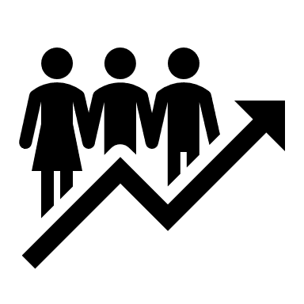 | Apply and practice communicating data through storytelling and visualization  - Apply and practice concepts learned during session in large and small group activities  - Opportunity to create a visual and share data story (CQLC Challenge)
Invitation and Application:
All interested partners are invited to apply to participate in the Coffee & Quality Learning Cohort. Please complete short application. As space is limited, 10-12 individuals will be selected based on quality of application and support from agency.

- Application Release: Thursday, January 14th
- Application Due Date: Friday, January 29th at 5pm to jdavison@unitedwayhouston.org
- Decision Notifications: Thursday, February 4th
- Please direct all questions to Jessica Davison, jdavison@unitedwayhouston.org

CQLC Time Commitment:
- Eight, 90-minute virtual meetings with medley of learning experiences (presentations, open discussion, article reviews, case study, technical practice). Learning Cohort members must commit to attending all virtual meetings. If more than one session is missed, the participant will be invited to join the next cycle for the cohort.
- Between session activities and discussion on private Microsoft Teams Channel.
- Check-in with CQLC facilitator on progress toward individual learning goal and data story.
- Between session time to create data story for CQLC challenge.
- Graduation ceremony to present data story with United Way staff and agency leadership.
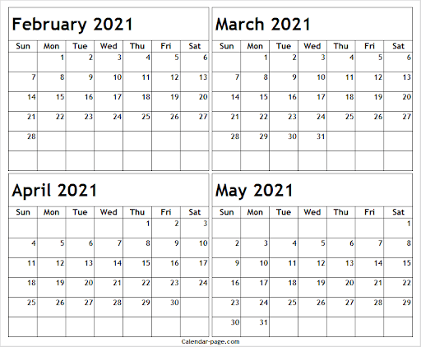
Learning Cohort Schedule: Sessions held from 9:00 – 10:30am unless otherwise noted. All sessions held via video conference.
February 2021: Tuesday, February 16th and 23rd
March 2021: Tuesday, March 2nd Thursday, March 11th
April 2021: Thursday, April 1st and 8th Tuesday, April 20th and 27th
May 2021: Thursday, May 13th from 9:00 – 11:00 am (Graduation)

Value Add:
- What’s in it for member: Learning Cohort that is valued to be worth over $1,000 per person. Deepen your knowledge and application of data visualization, grow professional network, enhance personal expertise and experience with communicating data effectively, and opportunity for an ongoing system of support and resources
- What’s in it for member’s agency: Internal staff with knowledge, resources, and abilities to communicate data effectively to support and promote agency’s mission.

Spring 2021 Coffee & Quality Learning Cohort Application
Applicant and Agency Information
Agency Name:
Name and Title:
Direct Phone Number:
Email Address:
Supervisor’s Name and Title:
Email Address:
Application Questions
  - Which Coffee & Quality sessions have you attended in the past? Select all that apply.
 |  | October 2019: Presentation and conversation on using data in difficult conversations and strategies for moving forward. |  |  | May 2020: CQI Team: Panel Discussion
 |  | November 2019: Logic Model in Use |  |  | August 2020: Survey Design: Theory & Best Practices
 |  | December 2019: Mechanics of Five-Why’s |  |  | September 2020: ALICE in your communities
 |  | January 2020: ALICE and the consequences of insufficient income |  |  | November 2020: Data Cleaning: Before and After
 |  | February 2020: Mastering the Follow-Up |  |  | December 2020: Talking Data with Staff and Stakeholders
 |  | April 20202: Navigating data quality during staff transition. (Viewed Webinar) |  |  | January 2021: Storytelling with data through data visualization
  - How have you incorporated concepts from Coffee & Quality into your work?

  - Does your agency support your participation in the Learning Cohort?
 |  | Yes |  |  | No
  - Describe what you hope to gain from participating in the Learning Cohort?

  - In a group setting, what role do you play?

- How do you anticipate applying the skills and concepts from the Learning Cohort into your work?

- What, if any, obstacles do you anticipate from applying the skills and concepts?

- Which of these audiences have you presented data to in the last year? Select all that apply.
 | Agency leadership (Chief Executive Officer, Chief Operating Officer, other C-Suite Officers, etc.) |  |  |  | Program leadership (directors, managers, coordinators, etc.)
 | Board members |  |  |  | Staff members (indirect or direct staff)
 | Clients or participants |  |  |  | None
 | Community members |  |  |  | Other:
 | Funders
- Which of these data visualizes have you created in the last year? Select all that apply.
 | Bar chart |  |  |  | Pictorial visualization
 | Dashboard |  |  |  | Pie chart
 | Flow diagram (flow chart) |  |  |  | Scatterplot
 | Geographic map |  |  |  | Treemap
 | Hexbin/Heatmap |  |  |  | Waffle chart
 | Infographics |  |  |  | None
 | Line chart |  |  |  | Other:
- What technologies have you used to visualize data? Select all that apply.
 | Canva |  |  |  | Power BI
 | D3 |  |  |  | Python
 | Excel |  |  |  | Tableau
 | Illustrator |  |  |  | R
 | Mapbox |  |  |  | None
 | Pen and paper |  |  |  | Other:

